Describing Contemporaneously Filed Attachments to Documents

CM/ECF creates a hyperlink within the document to contemporaneously filed attachments for court users when, during the upload process, they are described exactly as they appear in the main document. In addition, better attachment descriptions are very helpful to chambers. The following instructions will assist you with the process.
NOTE: Attach the Index of Exhibits (required under 7.6(b)) as the last attachment to keep the exhibits in order.
Step | Action
1 | Review the document you are preparing to file and note how the exhibits/attachments are referenced within the document. For example, Exhibit A or Ex. A.
2 | Begin the filing process by selecting the appropriate event. On the document upload screen, select the PDF “Main Document”. On the “Attachments” portion, select an entry from the Category if there is one that matches the naming convention used in the main document being filed. If there is no exact match for the description used in the body of the document in the Category box, go to step 3. 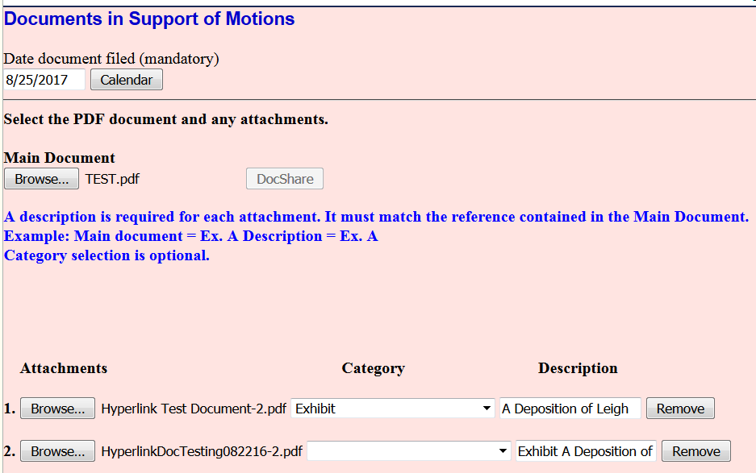
3 | If you selected an entry in the Category box add remaining text in the Description box such as the letter or number (Example: A or 1) and then briefly describe the exhibit/attachment to help chambers identify the attachments (Example: Deposition of Leigh Kinzer). If you did not select from the Category box, type the entire description in the Description box.
4 | The final text should fully describe the attachments and match the reference to them in the document.

