Scanned v. Converted PDFs
There are two ways to generate a PDF document that can be submitted into CM/ECF. The first method is to print a document onto paper. Then, using a scanner, the document is converted into a PDF. While this was the main method for creating a PDF in the past, this method creates problems for both CM/ECF and judges, who review the digital materials.
  - Method 1: Using a Scanner to Create a PDF from a Paper Copy — Try to Avoid
For instance, scanning the pages can create haphazardly slanted pages in the document Scanning the document into PDF also prevents people from (1) searching the document, (2) selecting, highlighting, or copying text in the document, and (3) makes any hyperlinks in the document unusable. For the court, these features are immensely helpful when reviewing attorney submissions.
There is one exception to this preference. (What is the law without an exception or three?) Attorneys should avoid submitting PDFs downloaded directly from CM/ECF—for instance, when an attorney wants to include an Order of the Court as an exhibit. Downloading the order directly from CM/ECF and uploading that PDF back into CM/ECF duplicates CM/ECF’s auto-generated headers, resulting in this:
Duplicated headers make it hard, if not impossible, to determine what page of the document the court is trying to cite. Therefore, if this is the case, attorneys should use a scanner to create the PDF. In all other cases, the court prefers the second method for generating a PDF.
Finally, deposition transcripts present a unique problem. Because transcripts typically contain hundreds of pages, deposition transcripts often contain four pages of testimony on every one PDF page to reduce the printed page length and digital file size. And because deposition transcripts are typically obtained from the court reporter present at the deposition, attorneys are not able to save or convert the transcripts into a fully searchable and selectable PDF, which means attorneys convert most transcripts into PDF by using a scanner. If possible, attorneys should either request the court reporter provide them with a fully searchable and selectable PDF for submission to the court. This will provide both the court—and opposing counsel—a manageable transcript file that is searchable and selectable.
  - Method 2: Using a Word Processor to Save/Convert to PDF — Try to Use
The second method for creating a PDF that CM/ECF will accept is easy. Simply use your word processing program (Word, WordPerfect, Pages, etc.) to save or convert the digital file to PDF. Most modern programs have this ability. In Microsoft Office 2010 (or greater), for example, the process is very simple:

- Go to File > Save As…
- Select the dropdown menu labeled “Save File As Type”—the highlighted box below:
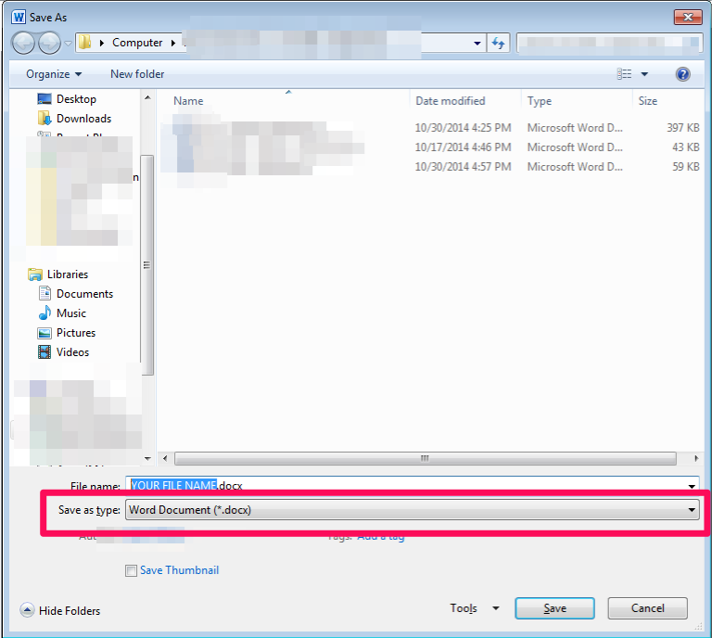
- Choose “PDF” from that dropdown box
- That’s it! Continue saving the document as you normally would.
If your word processing program does not feature the ability to save or convert into a PDF, there are several free conversion programs:
- The simplest one (and perhaps the best) is http://www.zamzar.com/. Simply follow the instructions and a fully searchable and selectable PDF will be emailed to whatever address you specify.
- CutePDF Writer is a free, Windows program.

Exhibits
Because most motions/memoranda contain exhibits, the court typically references those exhibits in its orders. Referencing exhibits can become confusing when one exhibit in CM/ECF actually contains multiple exhibits. This makes reading those PDFs hard; harder still is remembering what page of the attachment contains the particular exhibit that requires a citation. The court therefore prefers that attorneys adhere to a “one attachment, one exhibit” policy. Adhering to this policy will also make court orders more readable—compare (Doc. 62-1) & (Doc 62-2 at 3) with (Doc.62 at 3) & (Doc 62 at 108). It is a small difference, but one that makes things much more efficient, convenient, and logical.
Of course, some exhibits may contain additional materials that directly relate to an exhibited document, such as a letter that was sent with an attached document. For example, a conventional-mail letter chain between people, where the letters contain an enclosed copy of the previous letter. Attorneys may keep those documents together. Common sense typically governs. Generally speaking, the more weight a document has, the more likely it should be submitted as its own attachment.
Here are some examples:
- Letter from an Employer to an Employee with an enclosed copy of the Employee Handbook
  - Two Attachments: (1) letter to employee, (2) Employee Handbook
- Deposition Transcripts for Witness A and Witness B
  - Two Attachments: (1) transcript for Witness A, (2) transcript for Witness B
- A Cease and Desist Letter regarding an enclosed Patent
  - Two Attachments: (1) cease and desist letter, (2) Patent
- Letter Chain (conventional mail) between Attorneys
  - One Attachment, if on the same topic
- eMail Chain between People
  - One Attachment, if on the same topic

